AUTOPILOT ENGINE
FLIGHT CONTROL SYSTEM

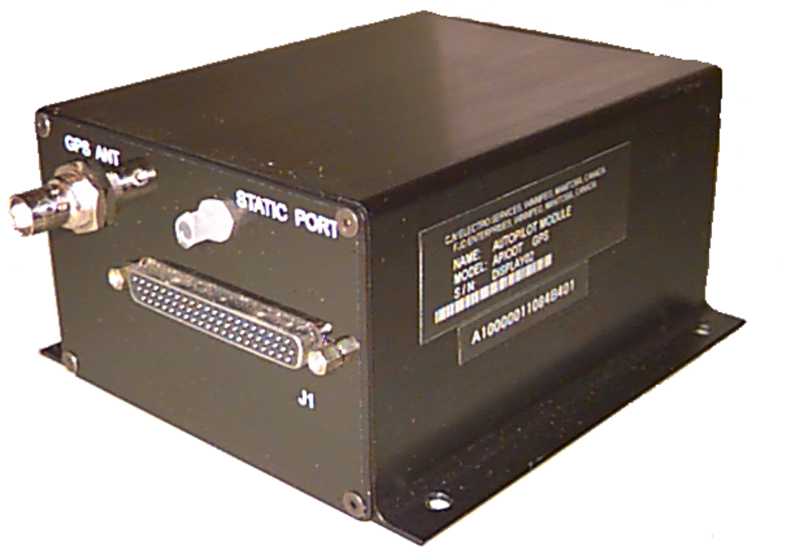

The Autopilot Engine Flight Control System provides the necessary vehicle controls to effectively operate small-scale remotely-piloted vehicles in a Radio Controlled (RC) environment. The system is based on a microprocessor controlled autopilot that controls all of the vehicle communications as well as providing integrated fail-safe functions for safe operation and VEHICLE recovery.
The Autopilot Engine consists of the Core Module, an Interface Printed Circuit Board (PCB) along with additional optional add-on modules for increased operating performance.

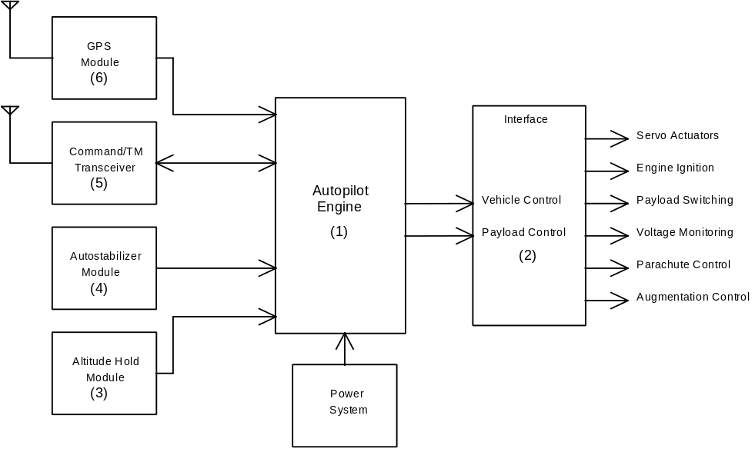

The Autopilot Engine (1) receives data from the Portable Ground Control Station (PGCS) and controls the required Vehicle and Payload Management Systems (2). The Vehicle Management System is designed to monitor the onboard sensors, operate flight control servos as well as a parachute deployment mechanism. The Payload Management System includes power switching for payloads such as Miss Distance Indicators (MDIs), radar transponders, etc., and an optional pyrotechnic ignition system for smoke canisters and/or infrared (IR) flares.
The addition of the Autostabilizer (3) and Altitude Hold (4) modules simplifies vehicle control functions and reduces the cost of operations by virtually eliminating lost vehicles due to operator error or poor visibility conditions. The incorporated fail-safe and vehicle monitoring system can warn the operator of potential system problems and prevents the vehicle from leaving the designated flight space when a loss of command link or system failure occurs.
The Autopilot Engine's flexibility allows interfacing to a simplex, half, or full duplex Radio Frequency (RF) system for increased communication requirements. The Command Transceiver (5) is the standard half duplex RF system that increases flexibility by providing command up-link and telemetry (TM) down-link capabilities (i.e. bi-directional communication links) on a single radio frequency channel. The telemetry down-link provides the PGCS operator with vehicle status information concerning the vehicle’s systems (altitude, pitch and roll, RPM, throttle, etc.) and allows the addition of sensors such as GPS (6) for global positioning information.

Due to its flexible system architecture, the Autopilot Engine is easily expandable and upgradable to meet increased requirements or customized to address special needs.
The Autopilot Engine can provide a variety of payload control functions such as Pulse Width Modulated (PWM) outputs for proportional control, pulse width counting/measurement, voltage monitoring, switched outputs for on/off applications as well as interfacing to intelligent peripherals through serial communication ports.
This family of Autopilot Engines is capable of operating as: a basic vehicle and payload management system; as an Autostabilizer with wings-leveling and altitude-hold; or as a fully featured Autopilot providing multi-vehicle operations utilizing GPS and way-point navigation. The various models are upwards compatible providing a migration path to a fully featured autonomous system.

AUTOPILOT ENGINE SPECIFICATIONS
Input Power(Nominal): 6 and 12 VDC/200 mA
Inputs/Outputs: 8 Servo PWM (programmable format)
4 communications ports (GPS, RX, TX, AUX.)
3 channels Payload Power Switching
0/+6/+12 Volt Distribution Bus
1 set NC/NO 3 A Relay contacts
Engine RPM Measurement
Parachute Deploy/Release Control
Hardware Watchdog/Fail-safe System
Operating Temperature Range: -30°C to +60°C
Storage Temperature Range: -50°C to +100°C
Dimensions: 5.38"(136.5cm) x 5.12"(130.2cm) x 2.69"(73.2cm)
Weight: 1 lb. (0.45 Kg.)
Connectors: 62 pin D (Female) for input/output
BNC Jack installed with GPS option
Optionals:
GPS Module, 6 Channel DGPS Receiver, c/w active antenna (factory installed)
Input Power (Nominal) 12 VDC/250 mA
Autostabilizer and Autostabilizer with Altitude Hold Modules (factory installed)
Input Power (Nominal) 12 VDC/70 mA

- CJV invites requests for requirements other than those stated above.
* Specifications may vary according to particular customer requirements.
**This system will meet or exceed these specifications however operation is not guaranteed outside of these parameters.

